Basic home network diagram

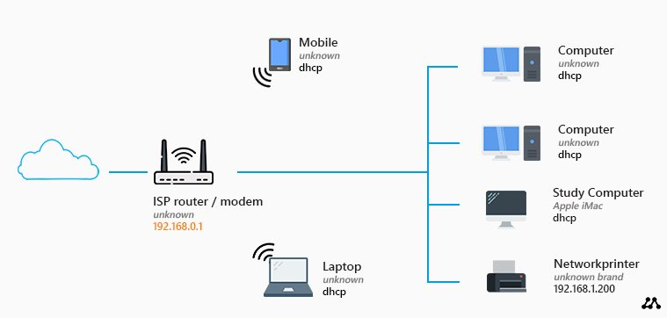

This is the most basic home network diagram that you can have. We have a router with a built-in modem and an access point that we got from our ISP (Internet Service Provider). These kinds of routers typically allow you to connect up to four devices using a network (UTP) cable.

**Pros**

If you live in a small house, and only have a limited amount of devices, then this basic network layout can work for you. You don’t have to buy any network equipment for this, so it’s really simple to setup.

**Cons**

If you look at this network diagram, you might think, this is all I need. I can connect my computer(s) and printer with a network cable and wirelessly connect my mobile phones and/or laptops.

**Tips**

If you are using this layout, make sure you change the default passwords for the router. The default password can easily be found on the internet, so to keep your network save, start with changing the passwords.

Also change the password, and network security key, from the wireless network, and disable WPS if it’s enabled in the router. Read more tips on s[ecuring your home network](https://lazyadmin.nl/home-network/home-network-security/).